Day 06 Highlights

1. Reminders
   1. Project One is due on Friday, January 25 at 5pm
   2. Quiz on Friday (practice quiz posted on Piazza)
   3. zyBooks Chapter 3 due Monday at midnight
2. Branches/selections – making a decision

**if ( expression )**

**statement1;**

**else**

**statement2;**

* 1. Relational Operators : **== != < <= > >=**

score>=60

b*b-4*a*c>=0

b*b<4*a*c

* 1. Logical operators **&& || !**

0<=score && score<=100

score<0 || score>100

!(0<=score && score<=100)

* 1. C operator precedence
  2. Implementation details
     1. Use **{** and **}** for multiple statements in then or else
     2. Don’t need **else** clause
     3. Can nest
  3. In C, the expression can be an arithmetic expression. For example, if(num%2){} // if num is odd

1. Write programs that
   1. reads a numeric score and prints “pass” or “fail”
   2. reads a numeric score and prints “pass” only
   3. reads a numeric score and prints its letter grade, A, B, C, D or F
2. Write programs for the following:

* Read a number and prints “odd” or “even”
* Read two integers and print the largest
* Read three integers and print the smallest
* Reads three integers and prints the range
* Read three integers and print a how many of them are the same (print “all three match” or “two match” or “no matches”)
* Reads three numbers and prints “ascending” if they are in strictly ascending order and “descending” if they are in strictly descending order and “no order” otherwise

**Flowchart**

Sequence

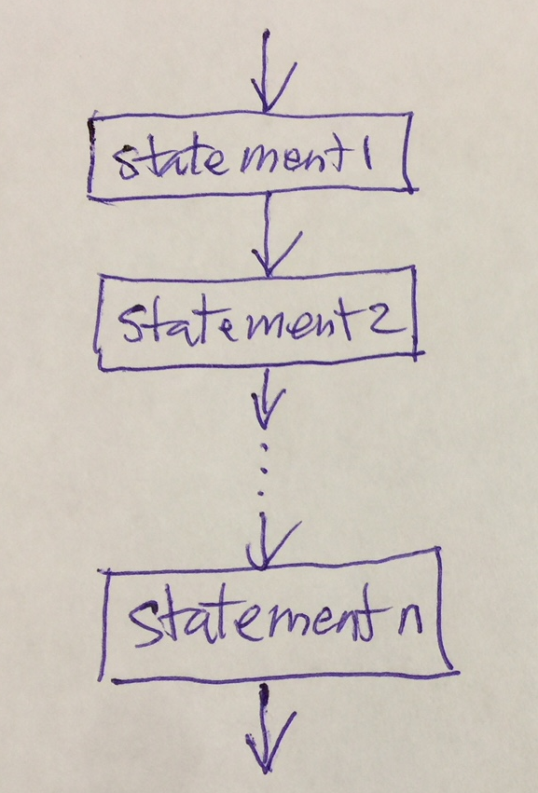

Selection

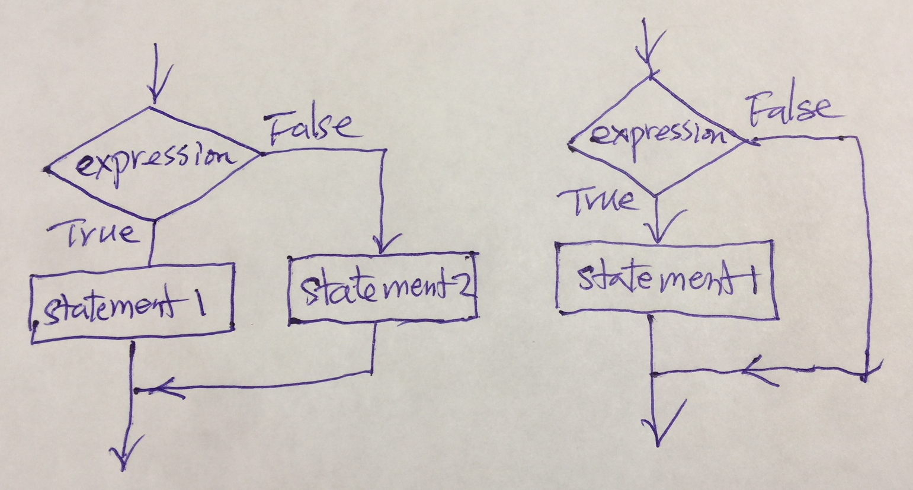

a). if with else b). if without else